MPGuino TFT Touch
Colourised by abbalooga

Congratulations on owning your very own MPGuino TFT Touch!!
Wow, what an accomplishment you have made. The very sight of your petrol being guzzled by your vehicle will give you the incentive to save hundreds a year on your fuel costs. Be sure to enjoy trying to get better and better economy as you learn more tricks to save fuel.

Disclaimer
This is by no way a brand new invention, and in fact the basic operation of this unit is an open source program obtainable from the interwebs. MPGuino is the name given to a code that uses an Arduino microcomputer to measure fuel usage. The MPGuino TFT Touch is simply an adaptation of the open source code, adapted to work on a more user friendly touch screen, with some added features to make life comfortable. All original source code is linked in below, and can be adapted for use as you please.

Basic Operation
To best understand how to calibrate your glorious new fuel saving toy, it would profit you to understand how it works. The MPGuino measures a speed pulse and one injector trigger signal. From these two pieces of information it can calculate some pretty neat stuff; like speed, distance, rpm, instant fuel usage, average tank usage and distance to empty. Over years of use it has been proven to remain accurate within 1% over each fill, which is more accurate that the fuel bowsers we use to fill our cars and calibrate the unit in the first instance. This is through the way the unit measures the fuel use, and will need to be understood in order to make your own calibration easy.
The MPGuino measures microseconds of injector time. This is the time that the injector is open. The fuel injector opens each cycle of the engine, and the duration it is open determines how much fuel it delivers to the engine. The unit of measure that is calibrated is microseconds per litre; the number of microseconds an injector is open to deliver one litre of fuel. This is a large, nonsensical number when you see it during calibration, but it is important to understand what the number is used for, in order to adjust it correctly.
Speed sense is less complicated, and is simply the number of pulses it takes for your car to travel 1km.

SETUP
Setting up your MPGuino requires some knowledge of a cars fuel injection system. The easiest way to find the wires you’ll need to tap into is to locate your vehicles ECU, normally located above the passenger’s foot well. Here you’ll find the required battery positive, negative, Speed signal and Injector Trigger wires you’ll need to tap into.
Each car manufacturer uses different colouring methods to identify which wires perform what duty, and for this reason we won’t be giving away any secrets here. Unfortunately you’ll need to either do some research online, or go hunting for them yourself.

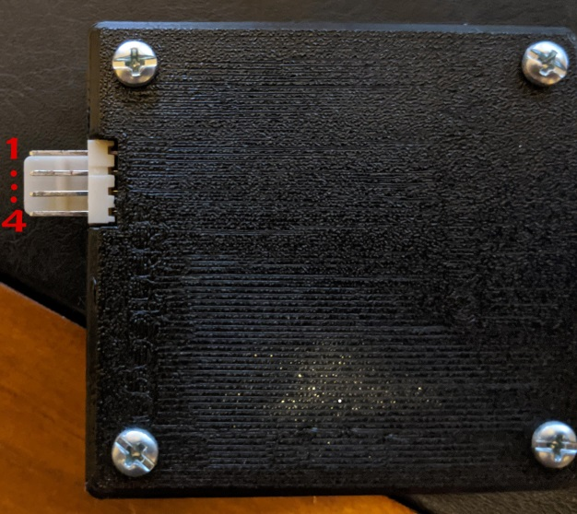
- Switched Positive. (RED) The MPGuino uses a very small amount of power to operate, and now saves data to the eeprom each time the vehicle comes to a stop. This means the MGPuino only requires a switched voltage source to operate. An easy way to find this would be to probe the ECU for a 12v signal that appears when the ignition is “ON” and disappears when the key turns back to “ACC” or accessories.
- Negative. (BLACK) Normally people consider black to be negative when wiring on a vehicle, but this is not always the case. Be sure to probe using your OHM meter to find a suitable earth. If for some crazy reason this is being installed on a positively earthed vehicle, you’re on your own.
- Injector Signal. (BLUE) This one may not be as hard. Again, “Google” can be your friend. Or take a look at your injectors on your engine. Each fuel injector will have a 12v power wire, and a negative trigger wire. It is this negative trigger wire we need. The best way to find this would be to pull the connector off the injector, and probe for voltage. When you see 12v with the ignition ON, you know the other wire is the negative trigger. Take note of the colour, and look on your ECU for this same wire. It may be a wire of thicker gauge compared to the rest.
- Speed Signal. (YELLOW) This unfortunately isn’t as easy to find. Different manufactures use different methods of calculating speed for their vehicles. In all test cases of vehicles with electronic fuel injection, the ECU has some kind of speed signal going to it. This may require the use of “Google” to find which particular wire you need to tap into. This wire cannot be measured easily with a multimeter either, as the signal is usually a pulse. If desperation takes hold, pull your speedometer apart and probe for the signal using an oscilloscope while the vehicle is in motion. If your vehicle has a speedo cable, this kit is not for you.

Positioning of the fuel computer and screen is ultimately up to yourself, however it is recommended that the screen be somewhere within view of the driver. This mesmerising information will be a distraction while driving and it is important to keep the road in your periphery while looking at the screen. Of course it is illegal to not look at the road while driving, and you may not obstruct your vision when installing items in your car. The fuel computer itself is best installed behind the dash near the opening of the glove box or underside of the dash near the driver’s feet. A USB cable for upgrading the firmware on the computer is included, and may be an option in the future. The screen cable is a fixed length of around 35cms and his shielding which is vital to the stability and usability of the screen. Keep this in mind when installing the items.
The easiest way of placing the screen seems to me to find an easily removable piece of trim and allow the ribbon cable to pass next to this panel when it is installed. Some double sided adhesive is sent with the kit for use however Velcro may be desired as an alternative. Be sure not to fold or crease the screen ribbon cable, and ensure the shielding remains over the cable for operation.

First use and calibration
Wow, here we are about to turn this thing on for the first time. The unit has been tested on Toyotas and Fords, however being a new product more testing may be required. The first thing to do is ensure the touch screen is working.

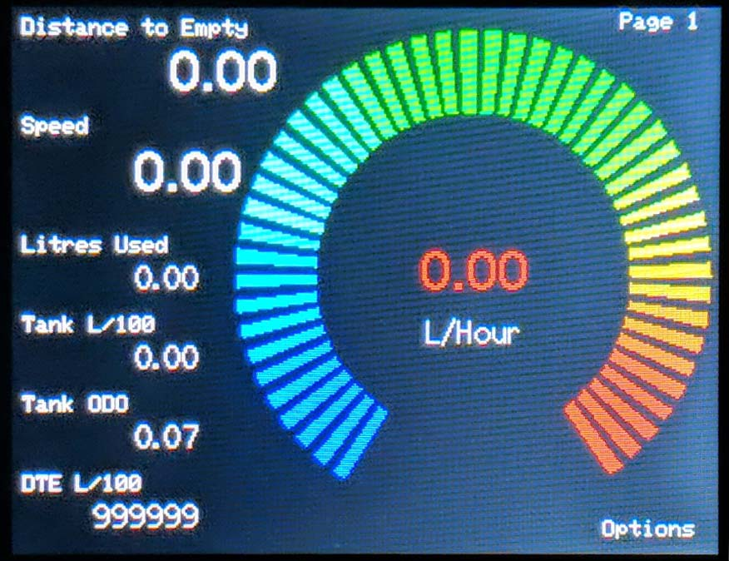
Press and hold the options corner of the screen for 2 seconds, followed by the setup button to enter setup.
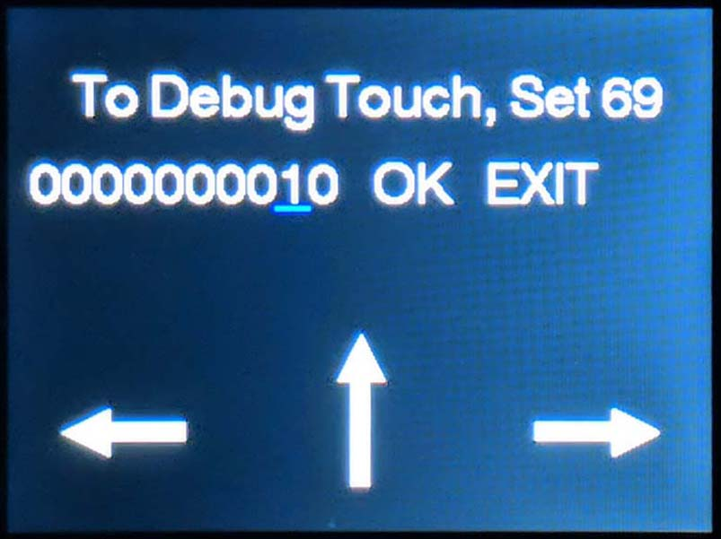
This screen is used to place debug information on the main screen, and only needs to be set when trying to debug an issue
To navigate the screen, left and right arrows are used to move the blue cursor, and the up arrow either changes the selected number, or confirms your selection. OK will save the current setting and proceed to the next config screen. Exit will exit back to the main screen of the unit, disregarding the change made to the current value.
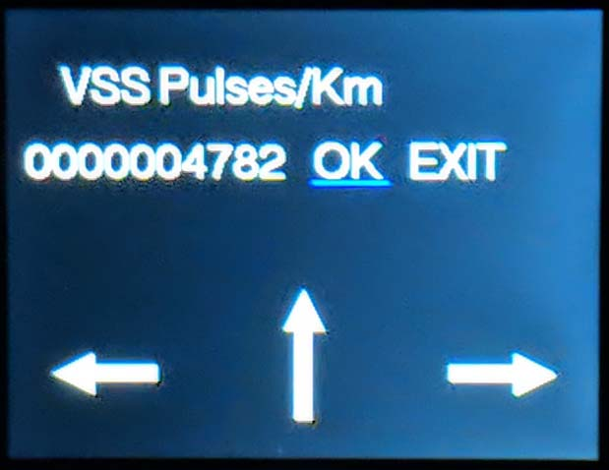
This value is the number of pulses the unit measures that equates to 1km or Mile travelled. Adjustment of this will be covered in the fine tuning section.
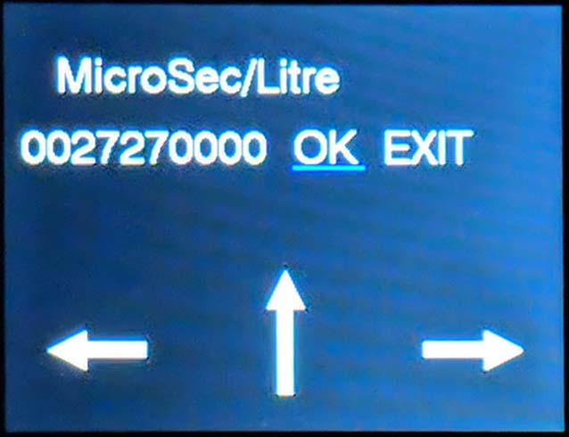
This value is the number of microseconds the unit measures that equates to 1 litre/gallon of fuel used. Adjustment of this will be covered in the fine tuning section.
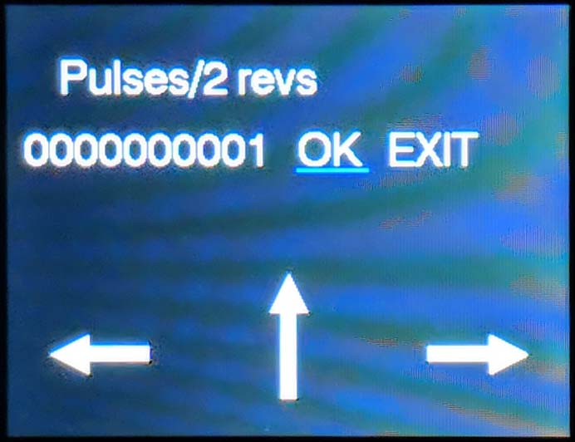
This is the number of injector pulses that occur per 2 revolutions of the engine. Some ECU’s will require this to be set to 2 to display the correct RPM
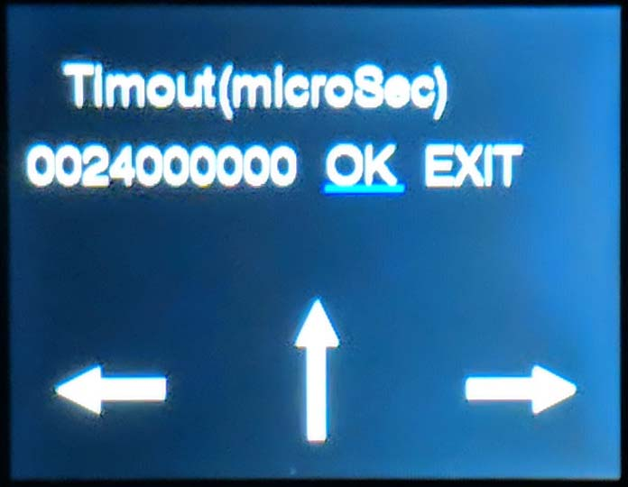
The screen may look pretty but we do not want it lit while the car is not in use. This value is the microseconds the screen stays on after the unit stops detecting touch or activity from the engine.
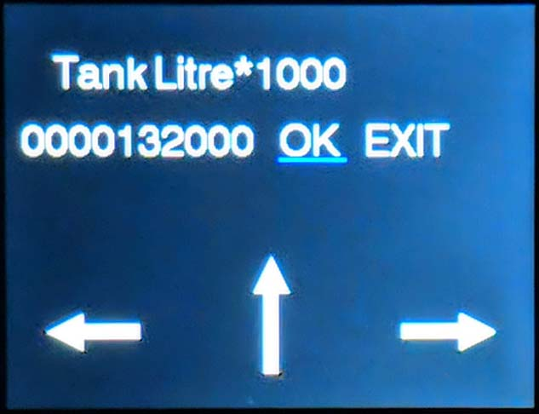
This is where the tank size is set to calculate distance to empty. It is recommended that you set this to the number of litres before your fuel light turns on. You can discover this amount during your setup.
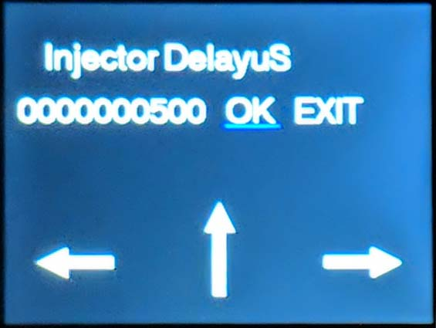
This measurement for fine tuning is the delay time taken from the start of each injector pulse signal to account for dwell time in the injector actually delivering fuel. This does not normally need adjusting
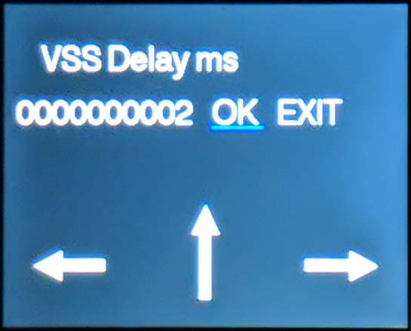
Like the Injector delay, this delay is used to help the speed pulse pickup the correct trigger. This does not normally need adjusting.
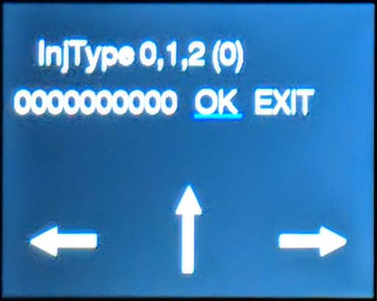
If you press the accellerator and your L/Hour value is geting smaller, then change this value from 0 to 1. If you press accellerator and this value is not changing almost at all, then maybe your car have ”Peak and Hold” type injectors and you could try value 2.
NOTE: After changing this setting and leaving settings menu, you must reset your MPGuino!

Main Screen Layout

Press and Hold here for 2 seconds to display different values in the main view
Press and Hold here to increase brightness

Press and Hold here to decrease the brightness
Press and Hold here for 6 seconds to enter the options menu

To stop erroneous screen changes it was important to add a delay in the time between pressing the screen and the action taken. A counter will show here to give feedback when a press is registered, and count up before the action occurs.
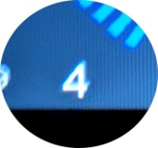

The Option Screen
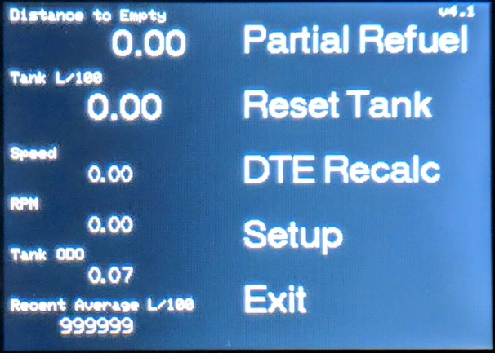
Here we find the different actions required to use the MPGuino effectively.
Partial Refuel: Is a function used when only partially refilling the tank, and maintaining an accurate distance to empty calculation.
Reset Tank: Used to reset calculation for the tank. This is done when the tank has been completely filled, and will reset the Tank litres used, Odometer and L/100 average.
DTE Recalc: Unfortunately the Distance To Empty recalculation requires some explanation. To calculate the distance to empty, the MPGuino requires a Litres per 100km measurement to then calculate how many Km’s are achievable from the remaining fuel. Sometimes this number may be better controlled by the user than resetting every time the tank is refilled. This is achieved by having a separate trip measurement only used for DTE calculations. The advantage to keeping this separate is say, leaving a long time average running, so when you refill your car and drive through peak hour traffic, your DTE will not assume horrible mileage and predict a very short tank distance. Or transversely, you may do a lot of city driving, then hit the open road for a road trip and want to accurately know how far you can drive with the exact driving style you’re implementing now, rather than the horrendous average set from yesterday’s peak hour. This method of seemingly adjusting your DTE number however you like does not change the accuracy of the DTE measurement, as it is only a tool to change the prediction of your future driving. The unit always knows how many litres you have left if your tank and will always approach zero Distance To Empty as you drive no matter how tricky you think you are. All you can do is trick yourself. TLDR: Pressing this resets the calculation for your distance to empty driving style
Setup: Enters the configuration menu for adjusting values
Exit: Exits to the main screen.
Partial Refuel Screen:
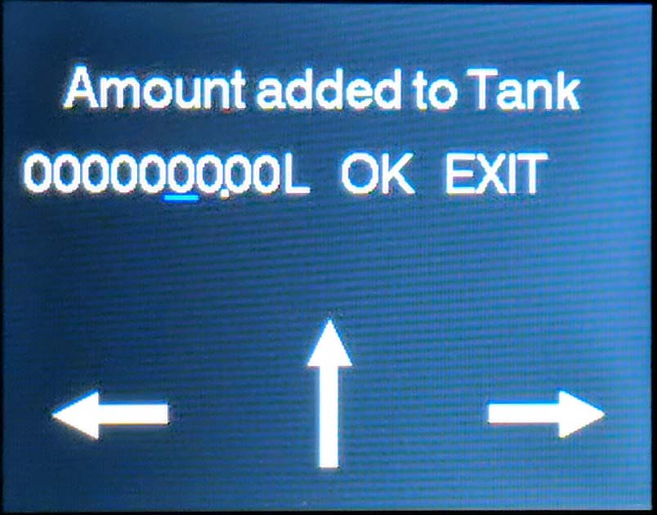
Here we find a screen for adding only a small amount of fuel to your tank. This will allow the DTE calculation to continue until you refill your tank completely the next time. OK will assume you have added the amount of fuel into your tank that you specify. EXIT will exit.
Here comes the fun part...
Speed Calibration
Speed calibration should be an easy task. Drive your car at 100kms per hour (or any speed, but the higher the calibration speed, the more accurate). You can either use your speedo if you want your MPGuino to match your vehicles displayed speed and odometer, or match it against a GPS if you want your speed to be accurate. If your MPGuino under reads speed, it needs to think less pulses are required to travel 1km. If your MPGuino over reads speed, it needs to think more pulses are required to travel 1km.
Scenario 1: Your speed on your MPGuino says 76km/h, but your GPS was a steady 100km/h. This means that the VSS Pulses number needs to be smaller. Go into the calibration screen and view the VSS Pulses/Km number(let’s pretend 4860). Divide 76/100. Then multiply your VSS number by the result (4860 x 0.76 = 3694). This will be your new VSS number.
Scenario 2: Your speed on your MPGuino says 123km/h, but your GPS was a steady 100km/h. This means that the VSS Pulses number needs to be larger. Go into the calibration screen and view the VSS Pulses/Km number(let’s pretend 4860). Divide 123/100. Then multiply your VSS number by the result (4860 x 1.23 = 5978). This will be your new VSS number.

Rough Fuel Calibration
This is where the initial time consuming part takes place. When your car is idling and the MPGuino displays Page 1, a Litres/Hour number should be displayed. This is a good starting point to get your MPGuino in a ballpark near where it should be. Over the vehicles tested, it was seen that a figure of 1.4 – 1.8 litres per hour was normal for a 4 to 8 cylinder car when at full operating temperature. First we will adjust the MicreSec/Litre figure to get this number within this range. Possibly on the higher side so when the final adjustment is made your fuel economy gets better instead of worse. Because of the large nature of the number used for adjustment, we will only work with the first 4 digits. So 27270000 will be treated as 2727. When making the adjustment, obviously change the numbers on the MPGuino accordingly.
Scenario 1: Let’s pretend the L/Hour figure is 3.5 and we want to change it to 1.8. This requires the Microsec/Litre number to be larger. (3.5/1.8) x 2727 = 5302. This will mean 53020000 will be entered into the MPGuino
Scenario 2: Let’s pretend the L/Hour figure is 1.1 and we want to change it to 1.8. This requires the Microsec/Litre number to be smaller. (1.1/1.8) x 2727 = 1666. This will mean 16660000 will be entered into the MPGuino.

Accurate Fuel Calibration
First Fill Up: This is important. In order to properly understand how much fuel your car uses to calibrate the MPGuino, you will need to fill your car up to the brim, “Reset Tank” on the MPGuino, then over consecutive days drive your car for at least a few 100kms.
Second Fill Up: When you next refill your car, be sure to brim it in the same manor you did previously. This can mean even using the same fuel bowser, and the same number of clicks you do to make sure it’s full. Whatever your ritual is, it must be repeatable. If for instance your first fill was quick, and your second fill you manage to get an extra 2 litres into the filler neck, you will have assumed your car has used 2 more litres than it really has.
Compare the Pair: Now it is time to compare the fuel used reading on the MPGuino to the fuel you filled your car with. The formula, if you haven’t guessed by now, is
(MPGuino Reading)/(Real World Reading) x MicroSec/Litre
Scenario 1: Your MPGuino thinks you used 45.3 and you fill your car with 62.5 litres. This means the MicroSec/Litre number needs to be smaller so for the measured time it thinks you used more fuel. So 45.3/62.5 x 2727 = 1976.529 which means 27270000 will become 19765290
Scenario 2: Your MPGuino thinks you used 71.4 and you fill your car with 62.5 litres. This means the MicroSec/Litre number needs to be larger so for the measured time it thinks you used less fuel. So 71.4/62.5 x 2727 = 3115.325 which means 27270000 will become 31153250
The more you can drive the more accurate the calibration will be. If you only refill 20 litres and there is an error of 1 litre difference in the way you fill, then the measurement is 5% inaccurate. If you refill 100 litres, and make a mistake of 1 litre when you fill, then the inaccuracy is only 1%.

Congratulations. You can now see how much fuel you use in real time. Wow... I hope that was all worth it for you. I did not enjoy writing that.

